SUMMER INTERNSHIP REPORT
Data Analyst
Training Details
Ground Floor, Indra Palace, H-16, Middle Circle, Block H,
Connaught Place, New Delhi – 110001
Internship In charge
Mr. Surakshit Kapoor - Training educator
Period
30 June 2026 to 11 July 2026

SUBMITTED BY
Ritika Saini - 2405170093
BCA -V semester


Department of Computer Applications
JAYPEE INSTITUTE OF INFORMATION TECHNOLOGY, NOIDA (U.P.)

Declaration

I hereby declare that the Summer Internship Report titled Data analytics project – employee payroll, mental health analysis, Athlete data analytics, online gaming behaviour is the outcome of my own work, carried out under the guidance of Mr. Surakshit Kapoor, and has not been submitted elsewhere for any other academic purpose.
Name of Student: Ritika saini
Signature
Date

Certificate
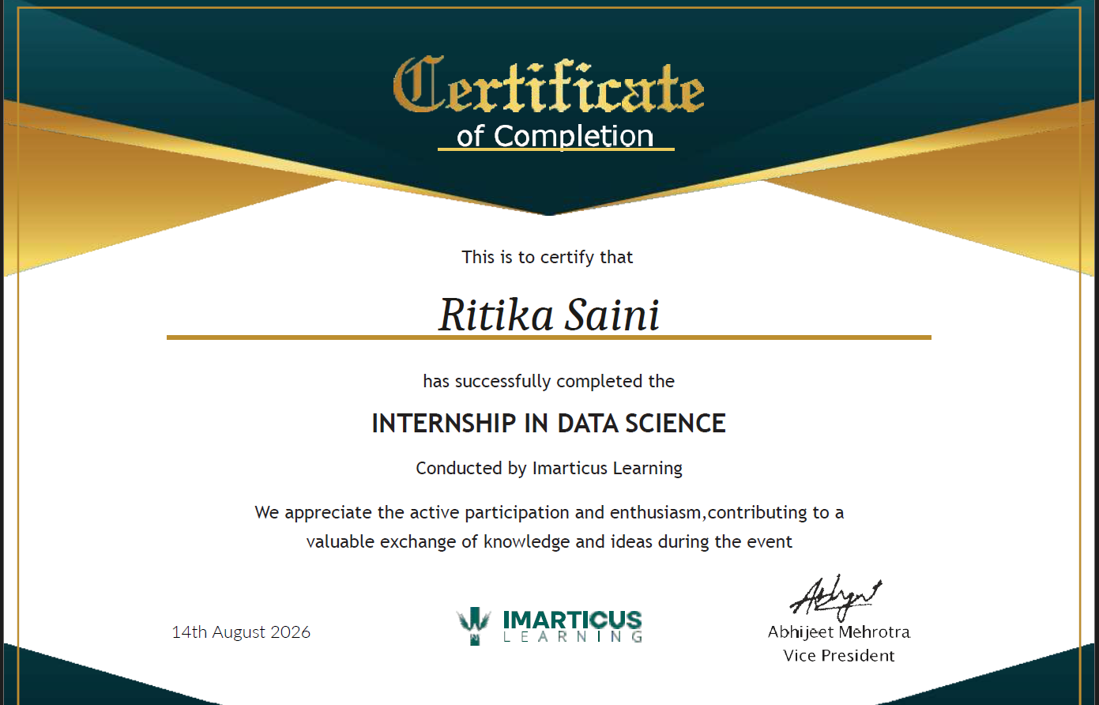
Acknowledgement
The time I spent in Imarticus Learning as a trainee June 30 – July 10, 2026 was a memorable one for me as it was rich in experience sharing and helped me to discover my potential. I have had so many experiences and opportunities that I believe will forever shape and influence my professional skills while fostering personal growth and development.
With a sage sense of gratitude, I acknowledge various people who directly or indirectly contributed to the development of this work and who influenced my thinking, behaviour & acts during training. I express my deep sense of gratitude to Training In charge Anil sir or in-house Surakshir Kapoor sir for his technical support and constant supervision which contributed immensely to my development. I also thank him for his guidance which was a remarkable force that enabled me to complete the training program.
I would like to thank my parents and my friends whose love and guidance are with me in whatever I pursue. Nobody has been more important to me than the members of my family and friends.
I also express my sincere gratitude to T&P Team, Jaypee Institute of Information and Technology, for their stimulating guidance, continuous encouragement and evaluating me on this training.

TABLE OF CONTENTS

No. | Section | Page
1 | Project Abstract | 6
2 | Introduction | 7
3 | Problem Statement and Objectives | 8
4 | Methodology | 9,10
5 | Weekly Progress Summary | 11
6 | Implementation | 12-15
7 | Learning outcomes | 16-19
8 | Future Scope | 20
9 | References | 21

1.Project Abstract
The six-week summer internship provided practical exposure to data analytics, data visualization, exploratory data analysis, and development of an interactive data platform. The internship was completed through a group-based set of assignments and projects covering employee payroll data, mental health survey information, Olympic athlete data, and an autonomous data platform. The employee payroll project focused on spreadsheet-based analysis of employee salary, experience, skills, promotions, and location-related information. The mental health project involved transforming survey data into an interactive Power BI dashboard for visual exploration. The athlete analytics project used Python libraries including Pandas, NumPy, Matplotlib, Seaborn, and Scikit-learn to perform data cleaning, missing-value treatment, outlier handling, exploratory analysis, feature engineering, encoding, and scaling on Olympic athlete data. The final technical project involved an Autonomous Data Platform with a Stream lit frontend and Fast API backend, supporting CSV upload, cleaning, data-quality inspection, search, automated insights, question answering, prediction, and recommendations. The internship also included a dedicated professional-development week covering resume building, LinkedIn profile development, communication, presentation, and interview preparation. Overall, the internship strengthened practical analytical thinking, programming, visualization, debugging, teamwork, documentation, and professional skills.

2. Introduction
2.1 Internship Domain
The internship was carried out in the broad domain of Data. Data analytics combines data collection, preparation, analysis, visualization, and interpretation to support informed decisions. Modern organizations use analytics for employee management, customer understanding, performance monitoring, forecasting, operational improvement, and strategic planning.
2.2 Importance and Motivation
The internship was chosen to gain practical exposure beyond classroom exercises. Academic courses introduce programming, databases, statistics, and algorithms, but professional projects require these concepts to be combined with messy datasets, business questions, visual communication, testing, documentation, and collaboration. The internship therefore provided an opportunity to practise a complete analytical workflow and understand how different tools are selected for different problems.
2.3 Real-World Applications
- Employee analytics can support salary analysis, workforce planning, promotion analysis, and skill-gap identification.
- Survey analytics can help organisations identify trends, patterns, and areas requiring attention.
- Athlete analytics can be used to study participation, physical characteristics, performance-related patterns, and historical trends.
- Autonomous data platforms can reduce repetitive data-preparation tasks and make analytics more accessible to non-technical users.

3. Problem Statement and Objectives
3.1 Problem Statement
Raw data is often stored in spreadsheets or CSV files and may contain missing values, duplicates, inconsistent formats, and large numbers of records. Analysing such data manually can be time-consuming and may make it difficult to identify useful patterns. In addition, different types of data require different analytical approaches: spreadsheet analysis is suitable for structured employee records, dashboards are effective for survey exploration, Python provides flexibility for large-scale EDA, and an integrated platform can combine cleaning, querying, insight generation, and prediction.
3.2 Objectives
- To understand the end-to-end data analytics workflow from raw data to useful insights.
- To analyse employee payroll and workforce-related information using spreadsheet techniques.
- To design an interactive Power BI dashboard for mental health survey analysis.
- To perform complete exploratory data analysis on Olympic athlete data using Python.
- To apply missing-value treatment, outlier handling, feature engineering, encoding, and feature scaling.
- To understand the architecture and implementation of an autonomous data platform using a frontend and backend.
- To practise professional skills including resume preparation, LinkedIn profile development, communication, presentation, and teamwork.
- To improve debugging, problem-solving, documentation, and project-presentation skills.

4. Methodology
A structured methodology was followed throughout the internship. Although the individual projects used different tools, the common analytical process was to understand the problem, inspect the available data, prepare the data, perform analysis, visualise results, validate the output, and document the findings.
4.1 Overall Workflow
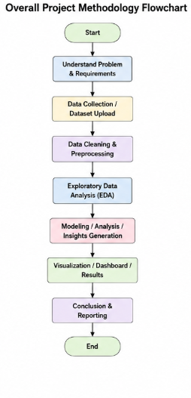
The workflow begins with problem understanding and data collection. The next stage involves data inspection and quality assessment. Data is then cleaned and transformed before analysis. Depending on the project, results are communicated through Excel summaries, Power BI dashboards, Python visualisations, or an interactive web platform. Testing and mentor feedback are used to refine the final output.

4.2 Dataset and Tools
Project | Data / Resource | Primary Tools
Employee Payroll Analytics | Employee records and payroll-related attributes | MySQL
Mental Health Analysis | Mental health survey data | Power BI / Power Query
Athlete Analytics | 120 Years of Olympic History – Athletes and Results | Python, Pandas, NumPy, Matplotlib, Seaborn, Scikit-learn
Online gaming behaviour | CSV datasets uploaded by the user | Python, Fast API, Stream lit, Pandas, NumPy, Scikit-learn, OpenAI API
Professional Development | Resume, LinkedIn and presentation activities | LinkedIn, document tools, presentation tools

4.3 Data Preparation
Data preparation differed by project. In the athlete analysis, missing values in Age, Height, and Weight were imputed using median values grouped by Sex and Sport, while Medal missing values were treated as a meaningful 'No Medal' category. Duplicate rows and textual inconsistencies were checked. Outliers were identified using the Interquartile Range method and capped rather than removed so that valid extreme athlete characteristics were retained.
4.4 Analysis and Modelling
The analytical stage included descriptive statistics, distributions, comparisons, trends, relationships, and engineered features. The athlete project created BMI, medal-status, age-group, decade, and country-event-diversity features. Categorical variables were encoded using label encoding or one-hot encoding, and continuous numerical variables were standardised using StandardScaler. The autonomous platform additionally included rule-based filtering, automated descriptive insights, simple linear-regression prediction, recommendations, and an AI fallback for natural-language questions.

5. Weekly Progress Summary
The internship was completed over six weeks. The following table summarises the actual progression from orientation and analytical projects to platform development, professional development, and final review.
Week | Major Activities | Outcome
Week 1 | Orientation, data-analytics fundamentals, employee payroll analysis in MySQL , joins, ranking, subquery ddl , dml and summary analysis. | Completed employee-focused analytical exercises and developed spreadsheet analysis skills.
Week 2 | Mental health survey analysis, data preparation and Power BI dashboard development. | Created an interactive dashboard and practised data transformation and visual storytelling.
Week 3 | Olympic athlete EDA using Python; cleaning, missing values, outliers, visualisation and statistical exploration. | Completed a structured EDA workflow and generated analytical insights.
Week 4 | Built a machine learning classification pipeline to predict player engagement levels from online gaming behaviour data. | Used PCA retaining 95% variance before KNN. Tested different K values for KNN, Created a model accuracy comparison.
Week 5 | Professional development: resume, LinkedIn, communication, presentation and interview-oriented activities. | Improved professional profile and workplace-readiness skills.
Week 6 | Final review, debugging, documentation, presentation preparation, progress diary checking and mentor verification. | Final work reviewed; weekly progress diary checked, marked and signed by the mentor/authority.

6. Implementation
The implementation phase consisted of multiple practical projects. Each project focused on a different aspect of the data analytics workflow and together they provided a broader understanding of spreadsheet analysis, dashboarding, Python-based EDA, and data-platform development.
6.1 Employee Payroll Data Analysis
The first project involved analysing an employee dataset containing 3 tables . The dataset included employee identifiers, names, email addresses, joining dates, job profiles, age, experience, gender, city, skills, salary, promotion date, percentage increment, months to promotion, updated salary, and skill count. The work was performed in MySQL using formulas, joins, subqueries, and summary calculation.
The analysis included city-wise average experience and salary, promotion status, maximum salary by location, employee skill counts, and activity-time. The updated salary field was used to understand the effect of percentage increments. This project demonstrated how spreadsheet tools can be used to convert raw employee records into structured business information.
Employees working on which project -> SELECT
e.first_name,
p.P_name
FROM Employees e
INNER JOIN Timesheets t
ON e.id = t.employee_id
INNER JOIN Projects p
ON t.project_id = p.id;
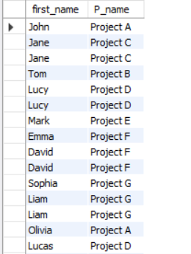
Rank of employees according to work they do ->
SELECT
e.first_name,
SUM(t.hours) AS total_hours,
RANK() OVER (ORDER BY SUM(t.hours) DESC) AS employee_rank
FROM Employees e
INNER JOIN Timesheets t
ON e.id = t.employee_id
GROUP BY e.first_name;
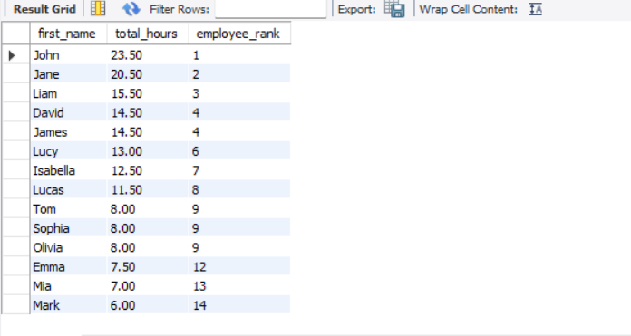

6.2 Mental Health Survey Analysis
The second project focused on analysing a mental health survey dataset using Power BI. The primary goal was to convert survey responses into an interactive analytical dashboard. The workflow included importing the data, checking and transforming fields, creating visual summaries, applying filters and presenting the findings through a dashboard.
Power BI was useful because it allowed multiple dimensions of the survey to be explored interactively. Visual elements and slicers helped users compare categories and inspect patterns without manually filtering the raw dataset. The project strengthened skills in data transformation, dashboard layout, visual selection, and communicating findings to a non-technical audience.
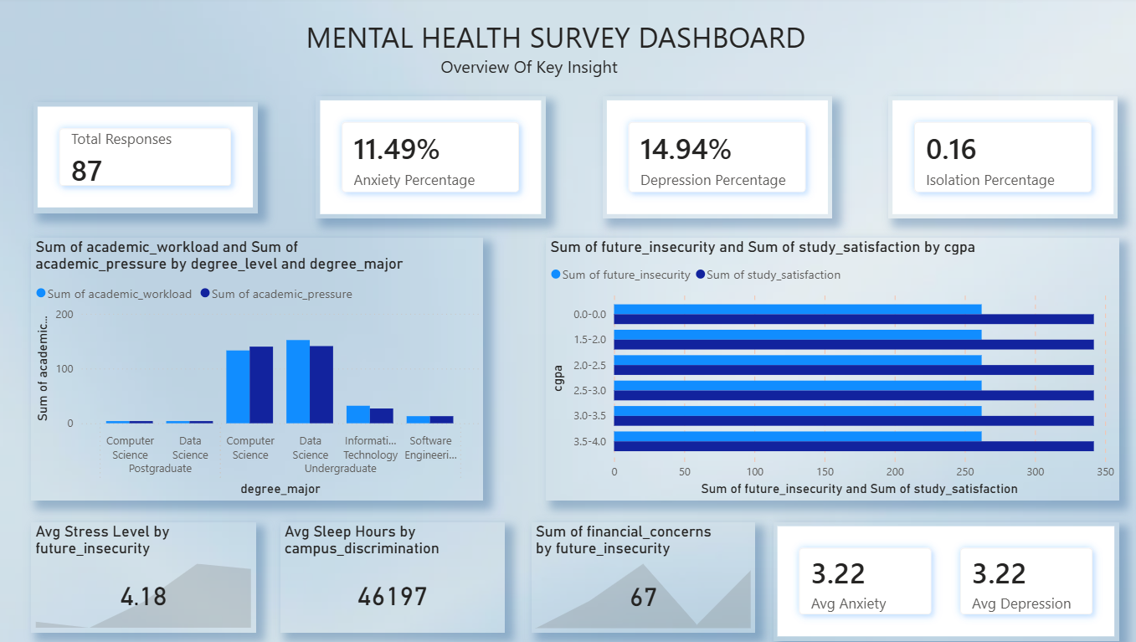

6.3 Athlete Data Exploratory Analysis
The third project was an Exploratory Data Analysis of the “120 Years of Olympic History – Athletes and Results” dataset. The dataset contains athlete information across Olympic Games from 1896 to 2016, including age, height, weight, sex, team, country code, Games, year, season, city, sport, event, and medal information.
The analysis began with dataset inspection, shape and data-type checks, duplicate detection, categorical value counts, and descriptive statistics. Missing values were then analysed. Medal values were converted from missing entries to the meaningful category “No Medal”, while Age, Height, and Weight were imputed using median values within Sex-and-Sport groups. This approach helped preserve realistic differences between sports.
Outliers in Age, Height, and Weight were identified using the IQR method. Instead of deleting records, extreme values were capped because an unusual physical measurement may represent a genuine athlete rather than an incorrect observation. Exploratory plots included distributions, participation by sex and season, top sports and countries, medal distribution, participation trends, height-versus-weight relationships, age comparisons, medal-winner analysis, country medal counts, and correlation analysis.
Feature engineering created BMI, Is_Medalist, Age_Group, Decade, and Country_Event_Diversity. High-cardinality categorical variables were label encoded, while low-cardinality nominal variables such as Sex, Season, and Medal were one-hot encoded. StandardScaler was then applied to continuous numerical variables, and the final processed dataset was exported for further use.

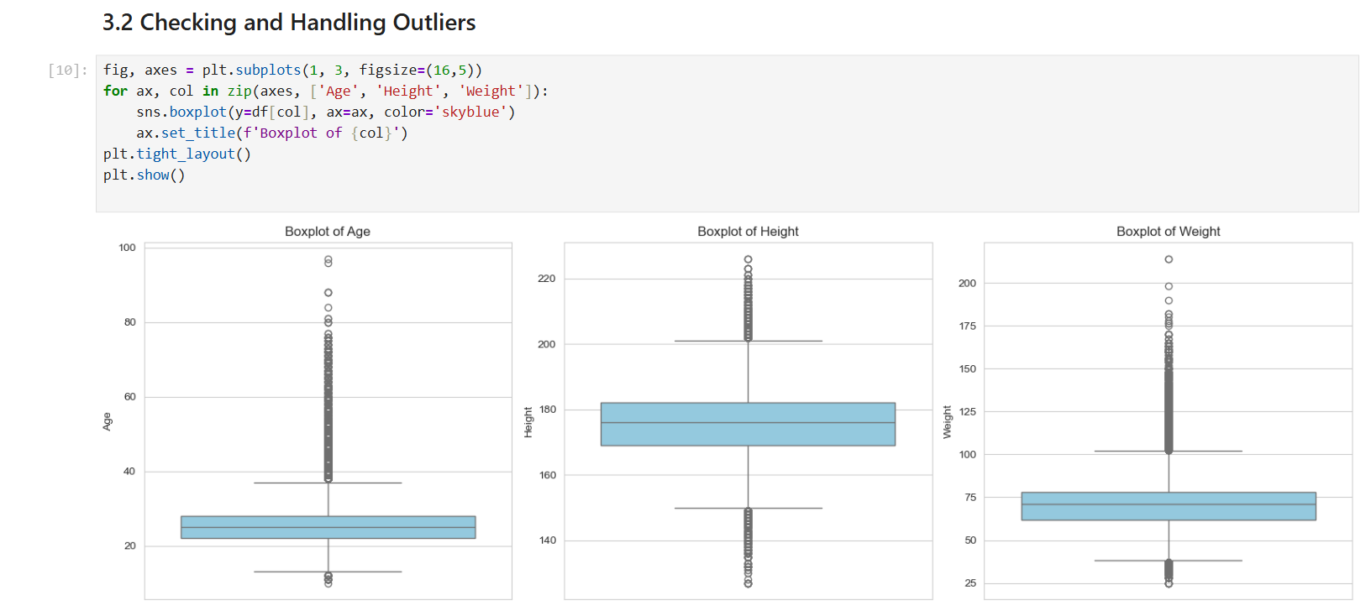
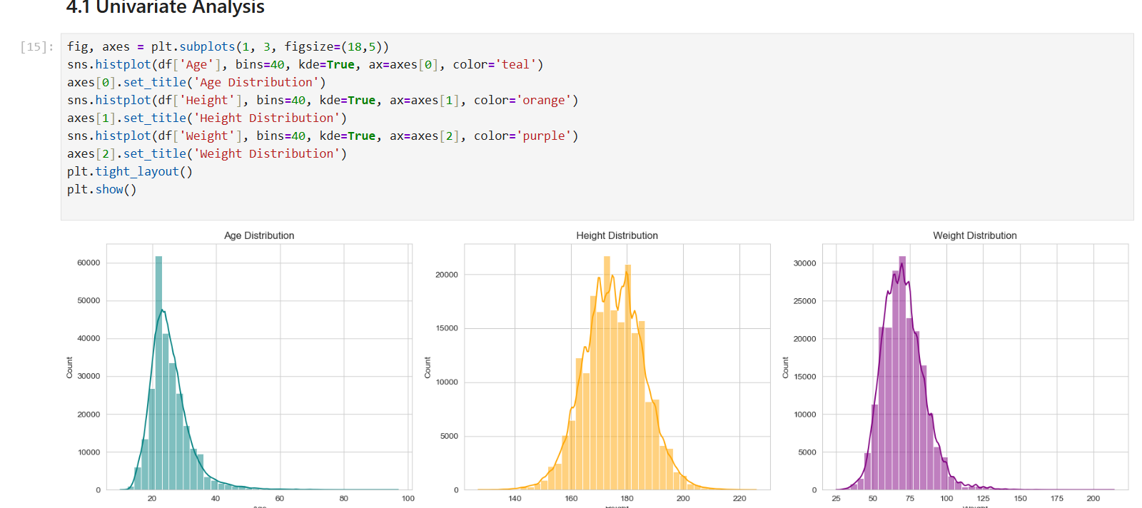

6.4 online gamming behaviour
Built a machine learning classification pipeline to predict player engagement levels from online gaming behaviour data. Prepared the dataset by removing redundant identifiers and duplicate records, encoding categorical variables, splitting data into 80/20 train-test sets, and standardizing numerical features. Implemented and compared Logistic Regression, Decision Tree, Random Forest, KNN and SVM classification models. Evaluated model performance using Accuracy, Precision, Recall, F1-score and Confusion Matrices to compare predictive performance. Applied PCA with 95% variance retention before KNN and tested multiple K values to evaluate model performance. Visualized model performance through confusion matrices and an accuracy comparison chart to support model evaluation.snippet: 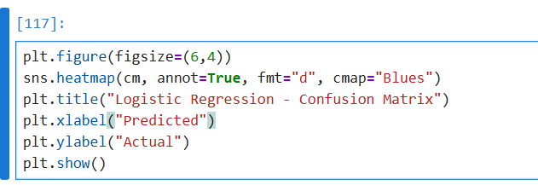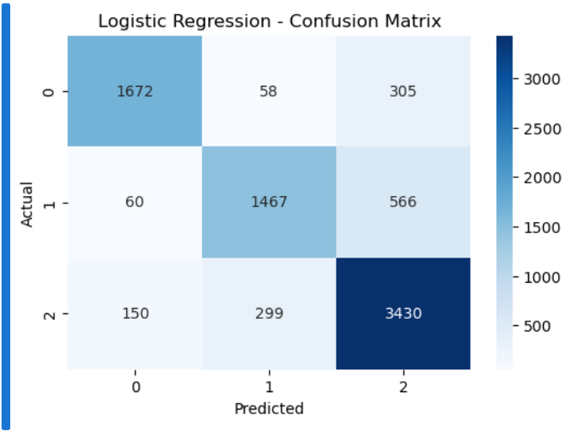
6.5 Professional Development and Soft Skills
One week of the internship was dedicated primarily to professional development. Activities included resume preparation, LinkedIn profile development, communication practice, presentation skills, interview preparation, professional etiquette, teamwork, and understanding workplace expectations. These activities complemented the technical work by helping translate technical knowledge into a professional profile suitable for internships and entry-level opportunities.

7. Results and Discussion
The internship successfully produced practical outputs across several stages of the data analytics lifecycle. The employee analysis demonstrated the ability to work with structured business records and calculate useful workforce metrics. The Power BI project demonstrated interactive visual reporting. The athlete project demonstrated a complete Python-based preprocessing and EDA pipeline. The Autonomous Data Platform integrated several of these concepts into a user-facing application.

7.1 Key Findings from Athlete Analysis
The Olympic dataset contained a substantially larger number of male athlete entries than female entries, although female participation increased over time.
Summer Olympic records represented a larger share of the dataset than Winter Olympic records.
Height and Weight contained significant missingness, particularly in historical records, demonstrating the importance of context-aware imputation.
The majority of athlete entries did not receive a medal, making “No Medal” an important analytical category rather than a conventional missing value.
Athlete physical characteristics vary naturally across sports, so extreme observations should not automatically be treated as errors.

7.2 Platform Results
Feature | Expected Outcome | Observed / Implemented Outcome
CSV Upload | Accept a dataset through the interface | Implemented through Streamlit and FastAPI upload endpoint.
Data Cleaning | Remove duplicates and prepare data | Implemented duplicate removal, forward filling and column standardisation.
Data Quality | Show missing values and duplicates | Implemented summary response and frontend display.
Search | Find records by a user query | Implemented case-insensitive search across dataset values.
Insights | Generate basic descriptive insights | Implemented mean, minimum, maximum and frequent-category summaries.
Ask Data | Answer natural-language questions | Rule-based filtering with AI fallback was implemented.
Prediction | Generate future numeric predictions | Linear Regression based five-step prediction was implemented.
Recommendations | Provide simple data-driven suggestions | Basic automated recommendations were implemented.

7.3 Challenges and Solutions
Challenge | Approach Adopted
Missing and inconsistent data | Inspected missingness and applied context-appropriate imputation and cleaning.
Extreme athlete values | Used IQR-based detection and capping while retaining legitimate observations.
Large categorical data | Used label encoding and one-hot encoding according to variable type.
Different project tools | Followed separate workflows for Excel, Power BI, Python and web-platform development.
Backend/frontend integration | Used FastAPI endpoints and HTTP requests from the Streamlit frontend.
Natural-language data queries | Combined rule-based filtering with an AI fallback mechanism.
Final documentation and verification | Reviewed the work, prepared the report, and completed sixth-week progress-diary checking and signing.

7.4 Limitations
The employee and survey analyses were based on the datasets available during the internship and therefore may not represent every real-world population.
The athlete analysis is historical and observational; correlation should not be interpreted as causation.
The Autonomous Data Platform uses a relatively simple prediction approach and is not intended to replace specialised forecasting models.
The AI question-answering component depends on an available API key and the quality/context of the supplied dataset sample.
The platform is a training/prototype system and would require stronger authentication, security, scalability, logging, and deployment controls for production use.

8. Learning Outcomes and Conclusion
Gained practical experience in applying data analytics concepts to real-world-style datasets. Improved proficiency in Excel-based data analysis, formulas, filtering, Pivot Tables, and business-oriented summaries. Developed practical Power BI skills in data preparation, dashboard design, visualisation, and interactive reporting. Strengthened Python skills using Pandas, NumPy, Matplotlib, Seaborn, and Scikit-learn. Learned practical techniques for missing-value treatment, outlier detection, feature engineering, categorical encoding, and feature scaling. Gained exposure to FastAPI, Streamlit, API-based application architecture, and integration of analytical functionality into a user-facing platform. Improved debugging, testing, problem-solving, and technical documentation skills. Developed communication, presentation, teamwork, resume-building, LinkedIn, and professional-profile skills. Learned to maintain weekly progress and incorporate mentor feedback into project refinement.

The six-week summer internship successfully connected academic learning with practical data analytics and software-development work. The projects covered a wide range of activities, beginning with spreadsheet-based employee analysis and progressing through Power BI dashboarding, Python-based exploratory data analysis, and an integrated autonomous data platform. The internship showed that effective analytics depends not only on writing code but also on understanding the problem, validating data, choosing appropriate methods, presenting results clearly, and communicating findings.
The internship also improved professional readiness through resume development, LinkedIn profile preparation, communication, presentation, and teamwork. The final review and signed progress diary provided formal closure to the six-week learning process. Overall, the experience strengthened both technical and professional capabilities and provided a practical foundation for further study and career development in data analytics, business intelligence, Python-based analytics, and data-platform engineering.

9. Future Scope
The projects developed during the internship can be extended considerably for real-world use. Future improvements can focus on automation, scalability, security, richer analytics, and production deployment.
- Extend the Autonomous Data Platform to support Excel, JSON, SQL databases, and cloud data sources in addition to CSV files.
- Add automated data-type detection, stronger missing-value strategies, duplicate profiling, anomaly detection, and data-quality scoring.
- Introduce more advanced forecasting and machine-learning models with proper train/test validation and model evaluation metrics.
- Add role-based authentication, secure API-key management, logging, audit trails, and privacy controls before production deployment.
- Improve the AI data assistant by using structured query generation, schema-aware prompting, validation, and safer handling of sensitive data.
- Add richer automatic visualisation and dashboard generation based on dataset characteristics.
- Deploy the platform on a cloud service to improve accessibility, scalability, and collaboration.
- Extend the employee and mental-health dashboards with more advanced KPIs and interactive drill-down analysis.
- Expand athlete analytics using predictive modelling, clustering, time-series analysis, and sport-specific comparisons.
- Develop a responsive web or mobile interface for broader access to the analytics platform.

10. References
- OpenAI API Documentation. https://platform.openai.com/docs/
- Kaggle / Olympic Athlete Dataset: 120 Years of Olympic History – Athletes and Results.
- Internship project files, datasets, notebooks, dashboards, and source code provided/developed during the summer internship.

